FizzBuzz Game Project Documentation

1. Introduction
The FizzBuzz Game is a Python program designed to demonstrate the use of loops, conditionals, and user input. In this program, the computer generates numbers from 1 to 100, while the user enters their own number each time. The sum of these two numbers is then checked for divisibility by 3 and 5 to determine whether the output should be 'Fizz', 'Buzz', or 'FizzBuzz'.

2. Explanation
for comp_num in range(1, 101):
This 'for' loop runs from 1 to 100. Each iteration assigns a new value to 'comp_num', representing the computer's current number in the game.
try-except Block:
try:
user_num = int(input("User -> Enter your number: "))
except ValueError:
print("❌ Invalid input! Please enter a valid integer.")
break
- This section ensures the program only accepts numeric input.
- If the user enters invalid input (like a letter or symbol), the program shows an error message and exits gracefully using the break statement.
- The try-except structure prevents the program from crashing.
Sum Calculation
total = comp_num + user_num
print(f"Sum = {comp_num} + {user_num} = {total}")
- This line adds the computer’s number (comp_num) and the user’s number (user_num).
- The result is stored in the variable total and displayed on the screen.
FizzBuzz Logic:

if total % 3 == 0 and total % 5 == 0:
print("FizzBuzz")
elif total % 3 == 0:
print("Fizz")
elif total % 5 == 0:
print("Buzz")
else:
print("No FizzBuzz match!")
After calculating the total, the program checks several conditions:
If 'total' is divisible by both 3 and 5, it prints 'FizzBuzz'.
If 'total' is divisible only by 3, it prints 'Fizz'.
If 'total' is divisible only by 5, it prints 'Buzz'.
Otherwise, it prints 'No FizzBuzz match!'.
These checks are made using the modulus operator (%) inside an if-elif-else structure.

Output
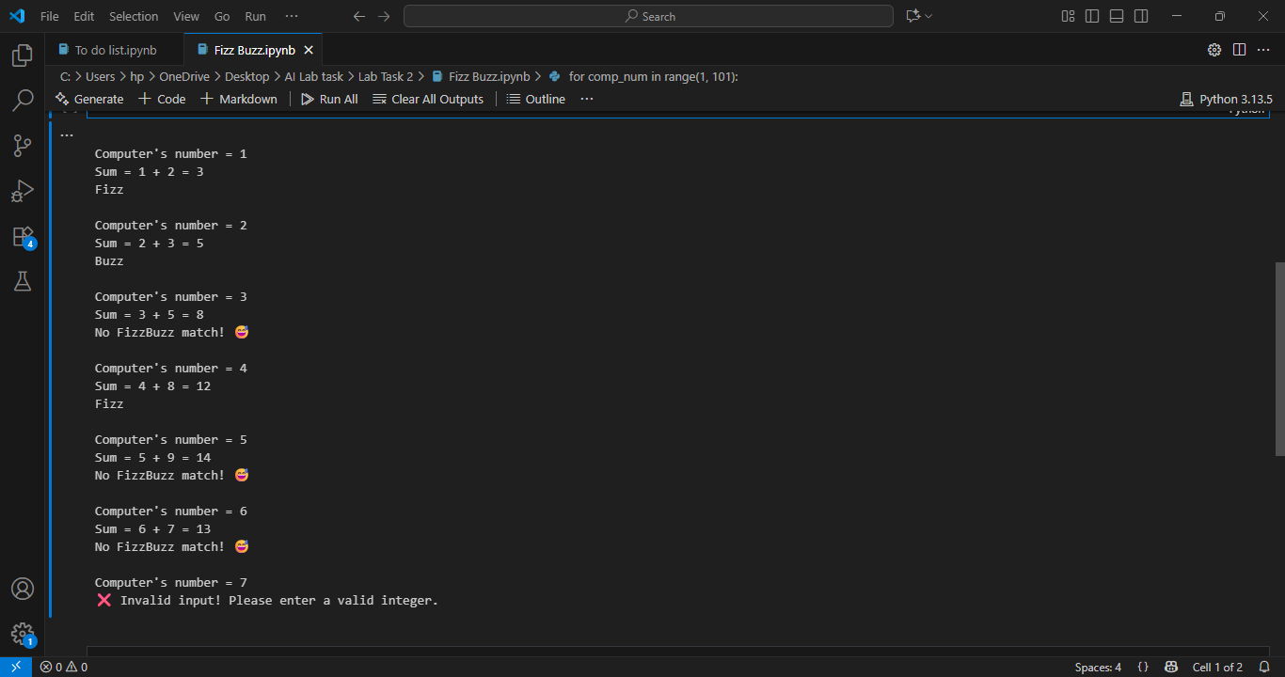

4. Key Python Concepts Used
Concept | Use in Project
FOR LOOP | Used to repeat the process for each number from 1 to 100.
TRY-EXCEPT | Prevents program crashes by handling invalid inputs.
IF-ELIF-ELSE | Implements the FizzBuzz decision-making logic.
MODULUS (%) | Checks if numbers are divisible by 3 or 5.
INPUT() | Takes the user's number as input.
PRINT() | Displays results and messages on the screen.
BREAK | Stops the loop when invalid input is detected.

5. Conclusion
This project is an excellent beginner-level Python exercise that covers important programming concepts such as loops, conditionals, user input, and exception handling. The FizzBuzz Game demonstrates how logical decisions can be made based on numeric conditions, making it a classic and fun problem for learning Python programming.

